Day in the Life of the Hudson River 10/13/22
Kowawese Plum Point, New Windsor, NY
RIVER MILE: 58.1
Salt Front: ~ Rm 76
Orange Co unty Water Authority – Sarah Archbald, MaryLynne Malone,
Orange County Homeschool Group - 23 students & 6 adults
Latitude 41.5° N & Longitude –74°W

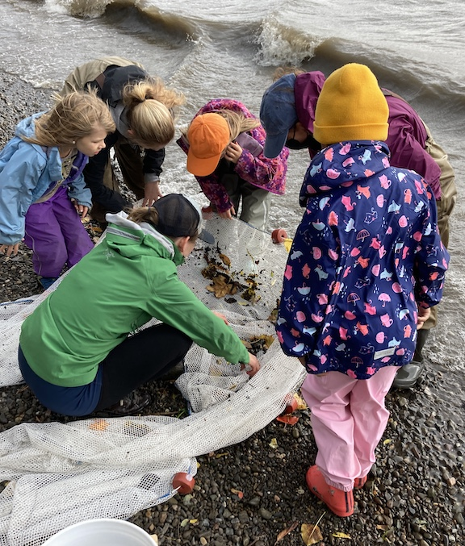 | 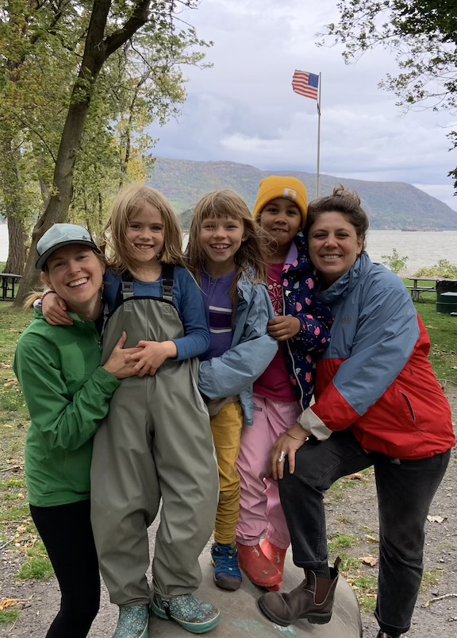 | 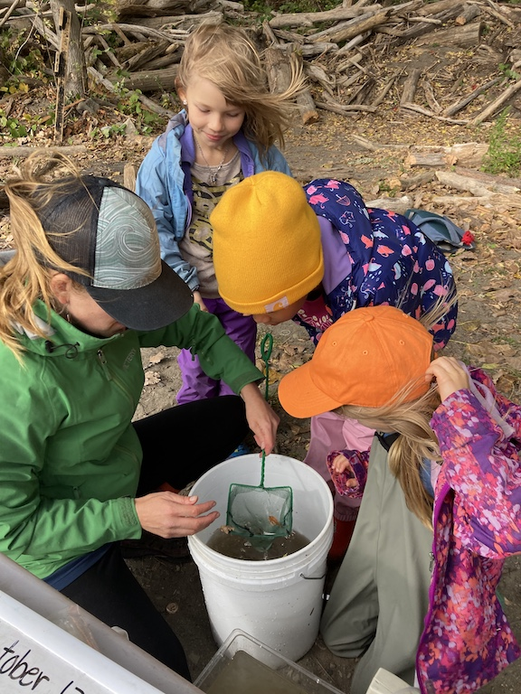 | 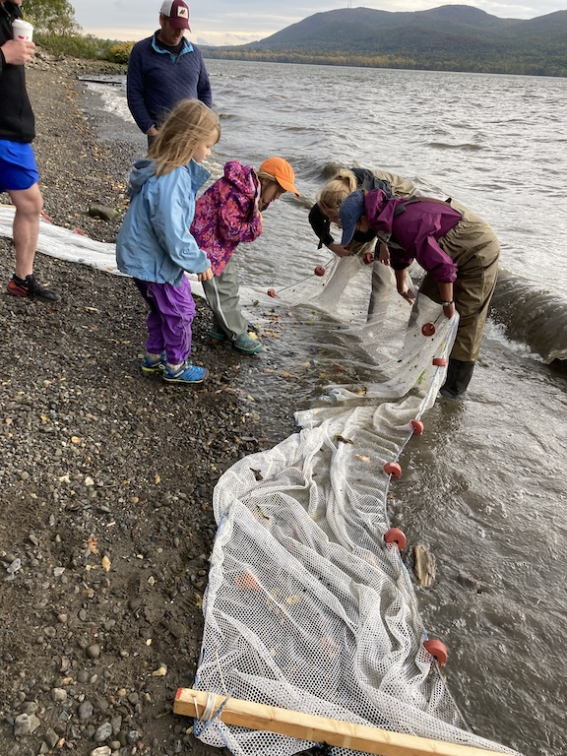

Location: Kowawese Plum Point, New Windsor, NY
Area: Orange County Park Kowawese Plum Point. Sampled on the southern shoreline, facing Storm King mountain, just to the right of the gazebo and central area of park.
Surrounding Land Use: 75% Forested, 25% Beach
Sampling Site: Forested, beach, grassy, parking lot, covered in vegetation
Shoreline: 75% Sandy, 25% Rocky
Water: Choppy; 30 cm deep
Plants in area: No plants in the water
River Bottom: Sandy & Rocky
*NR = Not read/recorded
ITEM |  | Time |  | Reading |  |  |  | Comments
Physical
Air Temperature |  | 9:20 AM  11:30 AM |  | 15° C  20° C |  |  | 60°F  68°F
Wind Speed: |  | 11:30 AM  2:00 PM |  | Anemometer  10-20 mph  27 mph |  |  | Beaufort  5  NR | Direction  S/SE  NR
Weather today |  | 11:30 AM |  | > 75% cloud cover |  |  | Start and Stop Rain
Weather the past 3 days: |  | High winds the previous afternoon but otherwise the previous 3 days were clear, crisp, warm seasonal weather
Tides- tide stick |  | Time |  | Rising, Falling, Unchanged |  |  | Water Height (cm)
 |  | 9:55 AM  11:30 AM |  | Rising |  |  | 0 cm  36 cm
Current- |  | Time |  | Cm/sec |  | Knots | North/South | Ebb/Flood/Still
Bay to south of Kowawese @ mouth of Moodna Creek |  | 11:45 AM  11:50 AM  11:55 AM |  | 12.7  26  15 |  | 0.25  0.5  0.3 | North  North  North | Flood  Flood  Flood
Water Temperature- |  | 1:12 PM |  | 18°C |  |  | 64°F
Turbidity- Long Sight Tube (120 cm) |  | 1:09 PM |  | 7.75 cm average |  |  | Very turbid!
Chemical
Salinity- LR Quantabs |  | 1:20 PM |  | LR Quantab 8.4 |  |  | > 1,113 ppm | *beyond detection
Standardized Salinity – HR Quantab |  | 2:23 PM |  | 1,807 ppm
DO – Hach Drop Count Kit |  | Time  2:01 PM |  | Temp  18°C |  |  | ppm DO  10 ppm | % saturation  105%
pH – NR
Nitrates- NR
Phosphates- NR
Alkalinity- NR
Biological
Fish – Seine |  | Number |  | Name |  |  | Length of longest | Length of smallest
10:15 –11:00 AM |  | 4  2  7 |  | American Eel  Atlantic Silverside  Striped Bass |  |  | 28 cm  11.4 cm | 25 cm  9 cm
Fish Totals |  | TOTAL: 13 |  | Diversity: 3
Macroinvertebrates |  | Number |  | Name |  |  | Length of longest | Length of smallest
 |  | 4 |  | Blue Crab
Macroinvertebrate Totals |  | TOTAL: 4 |  | Diversity: 1
Sediment Core - NA
Length | H2S smell |  | Oxid Top |  | Oil |  | Grain Size | Other Features
Boats-
 | Time |  | Name |  | Color |  | North/Southbound | Light/Loaded
Commercial | 2:20 PM |  | Barge |  | NR |  | Northbound | Loaded
Residential | 9:30 AM  9:45 AM |  | Sailboat  Speedboat |  | NR  NR |  | NR  NR | NR  NR

